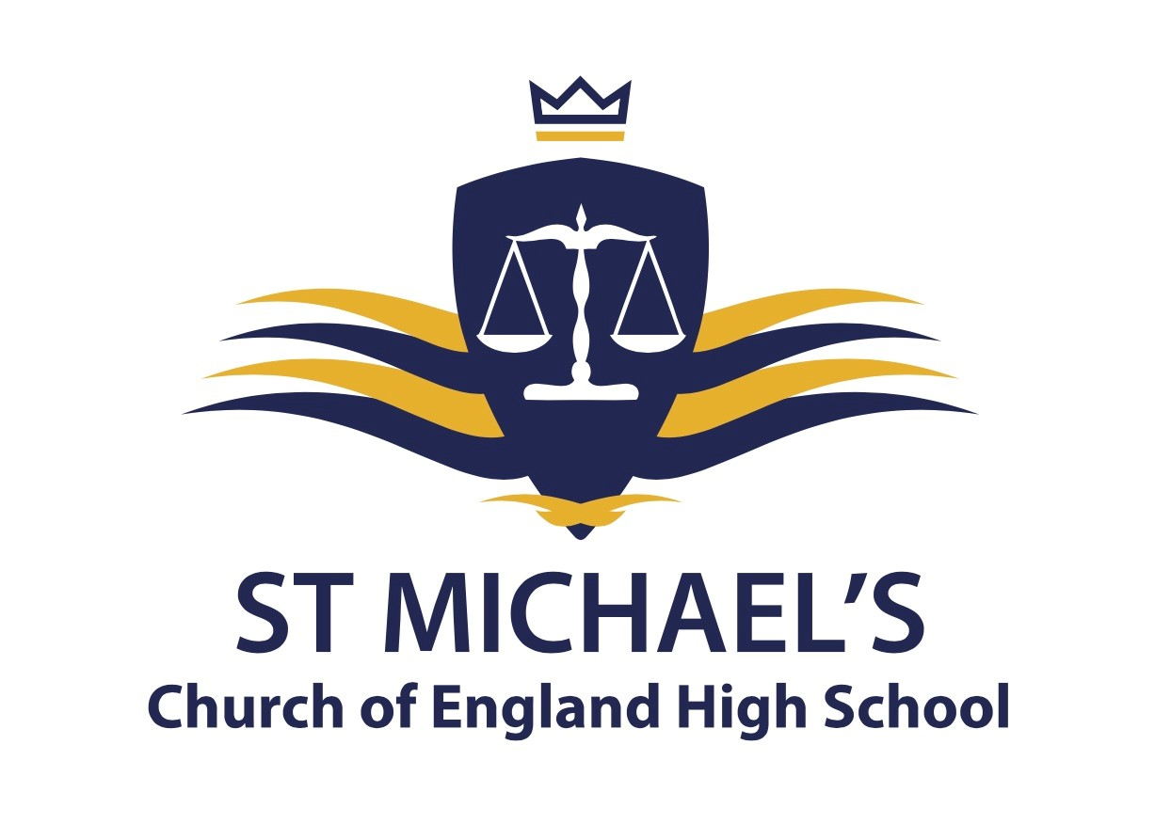

Bedrock Vocabulary is an online platform that enhances reading and vocabulary skills and is free to access for all new Year 7 students. The website provides both individualised learning programmes that are tailored to the strengths and development opportunities of each student, and regular knowledge checks to ensure progress is being made. Bedrock has been used at St Michael’s for three years and offered a means of maintaining literacy standards during lockdowns and school closures. Students who have participated in the programme have demonstrated significantly improved reading ages when compared to those not using the programme, as well as reading ages that well exceed the expected chronological improvement.

Over the summer, we are launching a competition to see which Year 6 students can engage with the programme the most. Those students with the highest engagement will be entered into a prize draw upon starting St Michael’s in September. This will be measured through the Bedrock points that each student accrues over the summer, prior to starting school in September.

Log-in details will be issued to all students on their transition days.

Should you have any access issues, I can be contacted via jack.knight@st-michaels.sandwell.sch.uk.

